Bansilal Ramnath Agarwal Charitable Trust’s
VISHWAKARMA INSTITUTE OF TECHNOLOGY – PUNE

CS2311: Software Engineering

Division |  |  | SY CS-A
Batch |  |  | 3
GR Number (PRN) |  |  | 12413610
Roll No. |  |  | 10
Name |  |  | ABHISHEK SARAF

Assignment 7

Problem Statement
- Prepare a software project plan with scheduling using Gantt charts and PERT charts for a sample project.

Gantt Chart
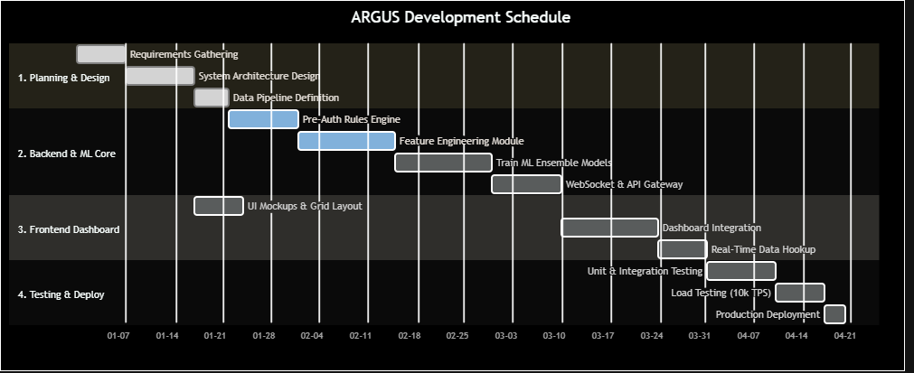

Gantt Summary Table
Task | Start | End | Duration | Dependencies
SoW Writing | W1 | W2 | 2 weeks | —
Architecture Design | W2 | W3 | 2 weeks | SoW
DFD / UML Diagrams | W3 | W4 | 2 weeks | Architecture
DB Schema Design | W3 | W4 | 1 week | Architecture
FastAPI Setup | W4 | W5 | 1 week | DB Schema
REST API + WebSocket | W5 | W6 | 2 weeks | FastAPI Setup
Data Prep & EDA | W4 | W5 | 1 week | DB Schema
Feature Engineering | W5 | W7 | 3 weeks | Data Prep
XGBoost Training | W6 | W7 | 2 weeks | Feature Eng.
Isolation Forest | W6 | W7 | 2 weeks | Feature Eng.
Ensemble + Threshold | W7 | W8 | 1 week | XGBoost + IF
Pre-Auth Engine | W5 | W7 | 2 weeks | REST API
Device Intelligence | W6 | W7 | 2 weeks | Pre-Auth
Graph Fraud Detector | W7 | W8 | 2 weeks | Pre-Auth
Phishing Protection | W7 | W8 | 2 weeks | Pre-Auth
Explainable AI | W8 | W9 | 2 weeks | All ML modules
Alert & Case Mgmt | W8 | W9 | 2 weeks | REST API
React/Vite Setup | W5 | W6 | 1 week | FastAPI
Dashboard UI | W6 | W8 | 3 weeks | React Setup
Charts & Simulation | W8 | W9 | 2 weeks | Dashboard UI
Integration Testing | W9 | W10 | 2 weeks | All above
Performance Tuning | W9 | W10 | 2 weeks | Integration
Bug Fixes | W10 | W11 | 1 week | Testing
README / SoW Final | W10 | W11 | 1 week | Testing
Pitch & Demo Prep | W11 | W12 | 2 weeks | All complete

Pert Chart

PERT Formula
O = Optimistic time (best case)
M = Most Likely time
P = Pessimistic time (worst case)
Expected Time: tₑ = (O + 4M + P) / 6
Variance: σ² = ((P − O) / 6)²

Task Estimates
Task ID | Task Name | O | M | P | t_{e}​ | σ²
T1 | SoW & Requirements | 1 | 2 | 3 | 2 | 0.11
T2 | System Architecture | 1 | 2 | 4 | 2.2 | 0.25
T3 | DFD + UML Diagrams | 1 | 1.5 | 3 | 1.7 | 0.11
T4 | DB Schema | 0.5 | 1 | 2 | 1.1 | 0.06
T5 | FastAPI Backend Setup | 0.5 | 1 | 2 | 1.1 | 0.06
T6 | REST API + WebSocket | 1 | 2 | 4 | 2.2 | 0.25
T7 | Data Prep & EDA | 1 | 1.5 | 3 | 1.7 | 0.11
T8 | Feature Engineering | 2 | 3 | 5 | 3.2 | 0.25
T9 | XGBoost Training | 1 | 2 | 4 | 2.2 | 0.25
T10 | Isolation Forest | 0.5 | 1 | 2 | 1.1 | 0.06
T11 | Ensemble Model | 0.5 | 1 | 2 | 1.1 | 0.06
T12 | Pre-Auth Engine | 1 | 2 | 3 | 2 | 0.11
T13 | Device Intelligence | 1 | 2 | 4 | 2.2 | 0.25
T14 | Graph Fraud Detector | 1 | 2 | 4 | 2.2 | 0.25
T15 | Phishing Protection | 1 | 1.5 | 3 | 1.7 | 0.11
T16 | Explainable AI | 1 | 2 | 4 | 2.2 | 0.25
T17 | Alert & Case Mgmt | 1 | 2 | 3 | 2 | 0.11
T18 | React Dashboard | 1 | 2 | 4 | 2.2 | 0.25
T19 | Charts & Simulation | 1 | 2 | 3 | 2 | 0.11
T20 | Integration Testing | 1 | 2 | 4 | 2.2 | 0.25
T21 | Performance Tuning | 0.5 | 1 | 2 | 1.1 | 0.06
T22 | Documentation | 0.5 | 1 | 2 | 1.1 | 0.06
T23 | Pitch & Demo Prep | 0.5 | 1 | 2 | 1.1 | 0.06

PERT Network Diagram
(START)
|
T1: SoW (2.0w)
|
T2: Architecture (2.2w)
| \
T3:DFD T4: DB Schema (1.1w)
(1.7w) | \
T5:FastAPI T7:Data Prep
(1.1w) (1.7w)
| |
T6:API(2.2w) T8:Feature Eng.(3.2w)
| | \
| T9:XGB T10:IF
| (2.2w) (1.1w)
| \ /
| T11:Ensemble(1.1w)
| |
T12:Pre-Auth(2.0w) T16:XAI(2.2w)
/ \ |
T13 T14 |
T15 T17 |
\ | T18:React(2.2w) |
\ | T19:Charts(2.0w) |
\ | | |
T20: Integration Testing (2.2w)
|
T21: Perf Tuning (1.1w)
|
T22: Documentation (1.1w)
|
T23: Demo Prep (1.1w)
|
(END)

Critical Path Calculation
Task | tₑ (weeks) | σ²
T1: SoW | 2.0 | 0.11
T2: Architecture | 2.2 | 0.25
T4: DB Schema | 1.1 | 0.06
T8: Feature Engineering | 3.2 | 0.25
T9: XGBoost Training | 2.2 | 0.25
T11: Ensemble | 1.1 | 0.06
T12: Pre-Auth Engine | 2.0 | 0.11
T16: Explainable AI | 2.2 | 0.25
T20: Integration Testing | 2.2 | 0.25
T21: Performance Tuning | 1.1 | 0.06
T22: Documentation | 1.1 | 0.06
T23: Demo Prep | 1.1 | 0.06
TOTAL | 21.5 weeks | 1.77

Resultant PERT Chart

Milestones
Milestone | Target Week | Description
M1: Design Complete | End of W4 | SoW, architecture, DFDs, DB schema finalized
M2: Backend Live | End of W6 | FastAPI running with REST API and WebSocket
M3: ML Models Trained | End of W8 | XGBoost + ensemble + all advanced modules working
M4: Frontend Complete | End of W9 | Full React dashboard with live simulation
M5: System Integrated | End of W10 | Full end-to-end system verified
M6: Demo Ready | End of W12 | Pitch, demo video, documentation complete

